**Restricting Movement**

**Objective**: In this video we are going to restrict the x range of movement of our ship, so that it can get to the edges of the screen without overshooting the edges. Also, we're also going to make the Rocket ship move.

Now the only problem we have is that the Rocket ship can fly off the screen.

Thankfully we have a function called Mathf.Clamp It restricts the output of the method

pos = Mathf.Clamp(rawPos, -10f, 10f);

The Clamp method takes an argument in this example its the Raw Position. If its between -10 and 10 then you just save the Raw Position. If it exceeds the range then it just gets set to the boundaries ie -10/10

**Challenge:** Your ships movement needs to be constrained to the screen. Ideally just use one number ± from the center.

1. lets add this line right **AFTER** the **newXPos** declaration. Lets create a new variable and called it **clampedXPos**

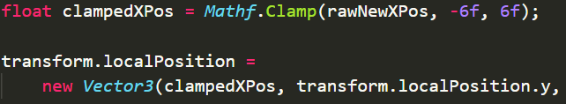

1. Lets create a [SerializeField] for this range so we don’t hard code it. At the top **under our controlSpeed** variable lets do this



and use our new variable



1. While we’re at it lets rename our **newXPos** to **rawXPos** since “New” didn’t really make sense anymore.



1. Make sure **clampedXPos** is being used as an argument for the Vector3 function



1. Go to Unity and play test your changes. Make sure your X Range number is set to something that makes your ship stop at the edge of the screen.

**Challenge:** Apply this clamped function to the Y position too

**Solution:**

1. Copy **clampedXPos** declaration line
2. rename **newYPos** to **rawYPos**
3. create a [SerializeField] for **yRange**
4. use **yRange** for the Clamp arguments
5. Replaced the y argument in the Vector3 function with **clampedYPos**

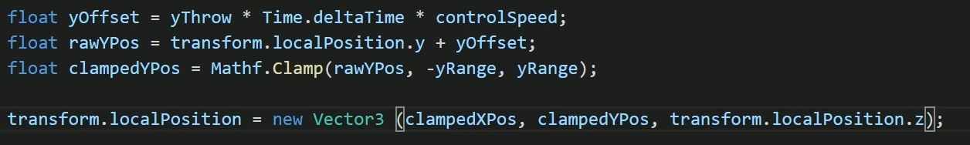

1. Go to Unity and test your changes. Adjust the Y Range value accordingly

**POTENTIAL BUG**

If the Player Ship had a good boundary for the bottom of the screen and not the top. Theres a good chance your game starts off with your ship at the bottom.

To fix this lower the Camera so your Ship is at the center of the screen when the game starts